Project Report Templeate

Tracing the growth of the global community: A population forecasting Analysis

1. INTRODUCTION

1.1 Overview

Population growth is the increase in the number of humans on earth. For most of human history our population size was relatively stable. But innovation and industrialization, energy, food, water, and medical care became more available and reliable.

1.2 purpose

Population growth gives scientists insight how organisms interact with each other and with their environment.

1. PROBLEMS DEFINITION & DESIGN THINKING

2.1 Empath map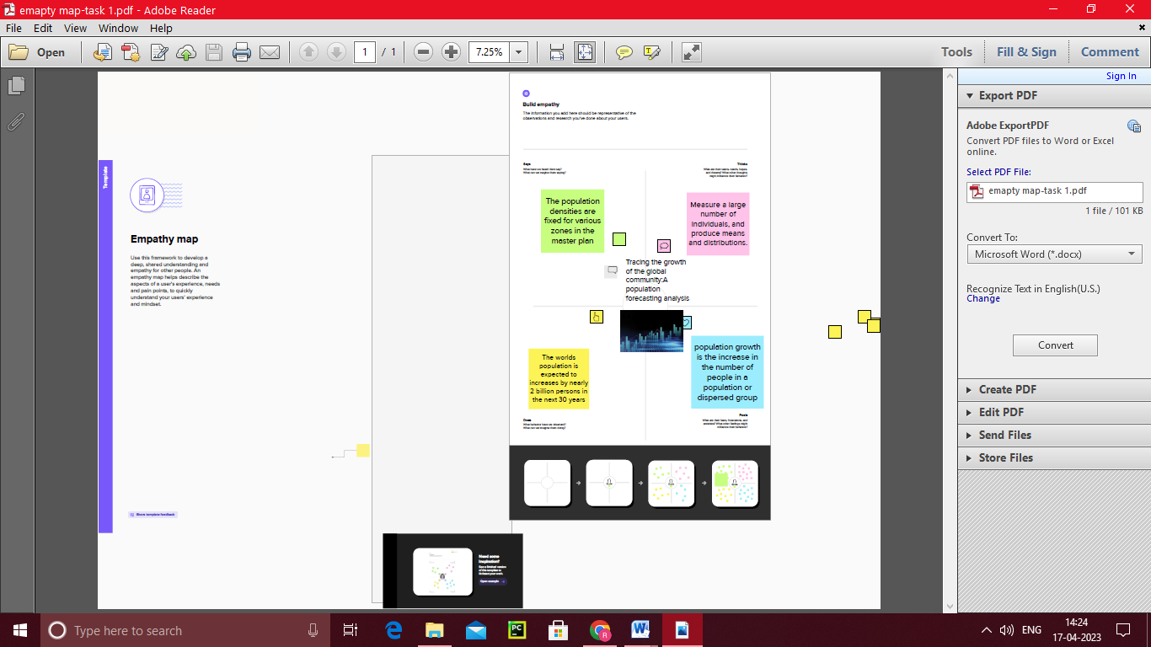

2.2 Ideation & Brainstroming map

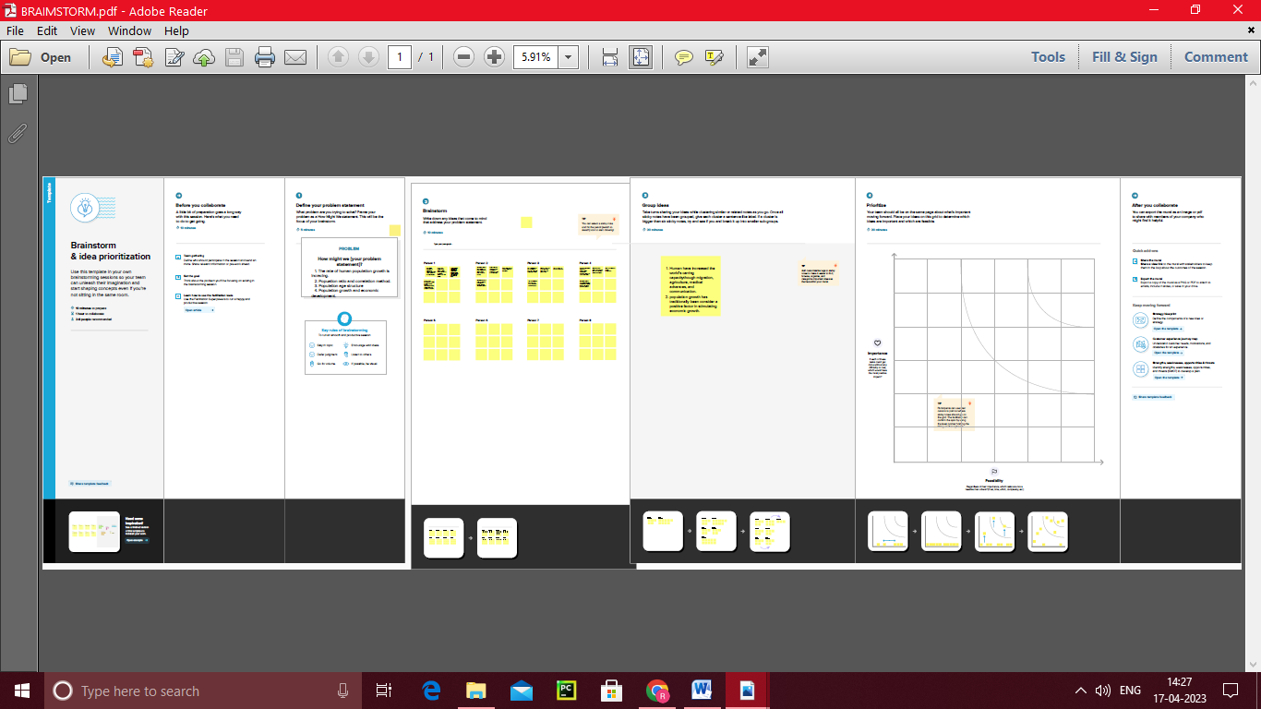

3.RESULT

Final finding (output) of the project along with screenshort

4.ADVANTAGES & DISADVANTAGES

Advantages

More people leads to greater human capital. Higher economic growth. Economies of scale. The efficiency of higher population density. Critical mass.

Disadvantages

Low per capita income. Low Quality of Life. Environmental Degradation and others. The number of unproductive consumers is increasing. Unemployment/ increased dependency.

5.APPLICATIONS

Population growth gives scientists insight into how organisms interact with each other and with their environments.

6.CONCULSION

It is expected to surpass 8 billion people by 2025, 9 billion by 2040, and 11billion by 2100.

7. FUTURE SCOPE

Enhancements that can be made in the future.

8. APPENDIX

A. source code

Attach the code for the solution built